Practice Sheet on View:
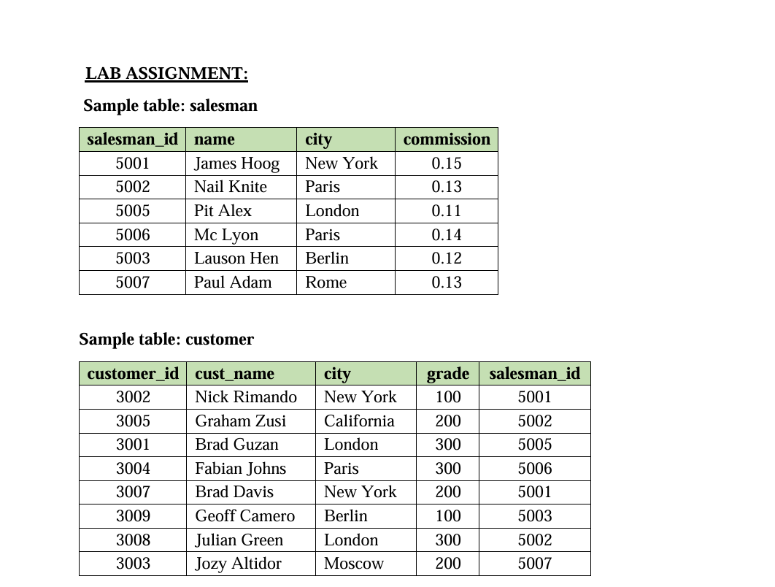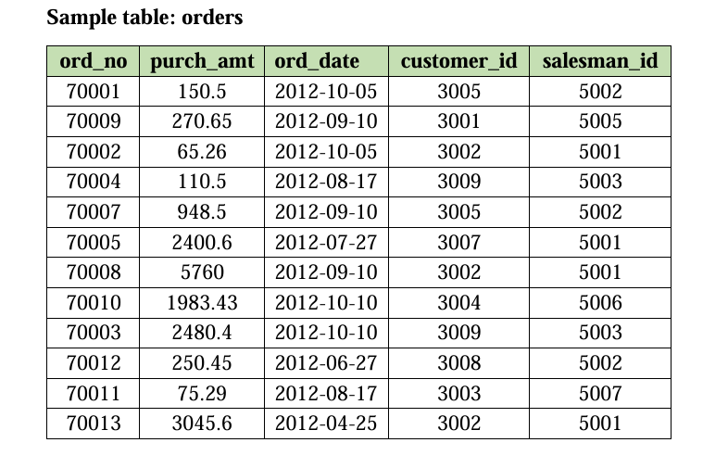
1. Write a query to create a view for those salesmen belongs to the city New York.
2. Write a query to create a view for all salesmen with columns salesman_id, name and

city.
3. Write a query to find the salesmen of the city New York who achieved the
commission more than 13%.
4. Write a query to create a view to getting a count of how many customers we have at
each level of a grade.
5. Write a query to create a view to keeping track the number of customers ordering,
number of salesmen attached, average amount of orders and the total amount of orders
in a day.
6. Write a query to create a view that shows for each order the salesman and customer
by name.
7. Write a query to create a view that finds the salesman who has the customer with the
highest order of a day.
8. Write a query to create a view that finds the salesman who has the customer with the
highest order at least 3 times on a day.
9. Write a query to create a view that shows all of the customers who have the highest
grade.
10. Write a query to create a view that shows the number of the salesman in each city.
11. Write a query to create a view that shows the average and total orders for each
salesman after his or her name. (Assume all names are unique)
12. Write a query to create a view that shows each salesman with more than one

customers.

13. Write a query to create a view that shows all matches of customers with salesman
such that at least one customer in the city of customer served by a salesman in the city
of the salesman.

14. Write a query to create a view that shows the number of orders in each day.
15. Write a query to create a view that finds the salesmen who issued orders on October
10th, 2012.

16. Write a query to create a view that finds the salesmen who issued orders on either
August 17th, 2012 or October 10th, 2012.

Practice Sheet on Indexing and Cascading:
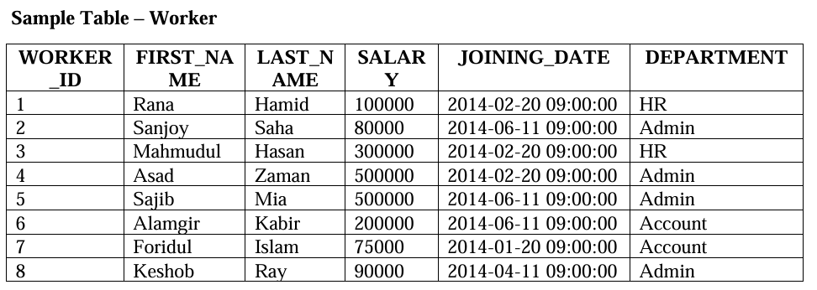

- Write the SQL query to create a non-unique index named idx_worker_salary on the SALARY column of the Worker table to speed up payroll queries.
- Write the SQL command to create a composite index named idx_name_dept on the Worker table using the FIRST_NAME and DEPARTMENT columns.
- Write the SQL statement to create a unique index named idx_worker_id_unique on the WORKER_ID column.
- Provide the SQL command required to delete an index named idx_worker_salary.
Part 2: Cascading Tasks
- Create a table named Departments with a Primary Key DeptID. Then, create a table named Staff where DeptID is a Foreign Key referencing the Departments table. Ensure that if a department is deleted, all staff members belonging to that department are also deleted from the Staff table.
- Given an existing table Orders with a column CustomerID, write the SQL statement to add a Foreign Key constraint named fk_cust_update that references a Clients table. The constraint must ensure that if a CustomerID is changed in the Clients table, it is automatically updated in the Orders table.
- Create a child table named Project_Tasks that references a parent table Projects. The parent table has a composite Primary Key consisting of ProjectID and DeptCode. Write the SQL to define the foreign key in Project_Tasks that uses both columns with an ON DELETE CASCADE rule.
- Write the SQL to create a Shipments table referencing a Warehouse table. The constraint must satisfy these two conditions:
  - Allow the WarehouseID to be updated automatically if changed in the parent table (Cascade).
  - Prevent the deletion of a warehouse if it still has active records in the Shipments table (Restrict).

